**HIVE**

To work with partitioning & bucketing using hive Create one base table.

**Step 1. Create a table in the Database**

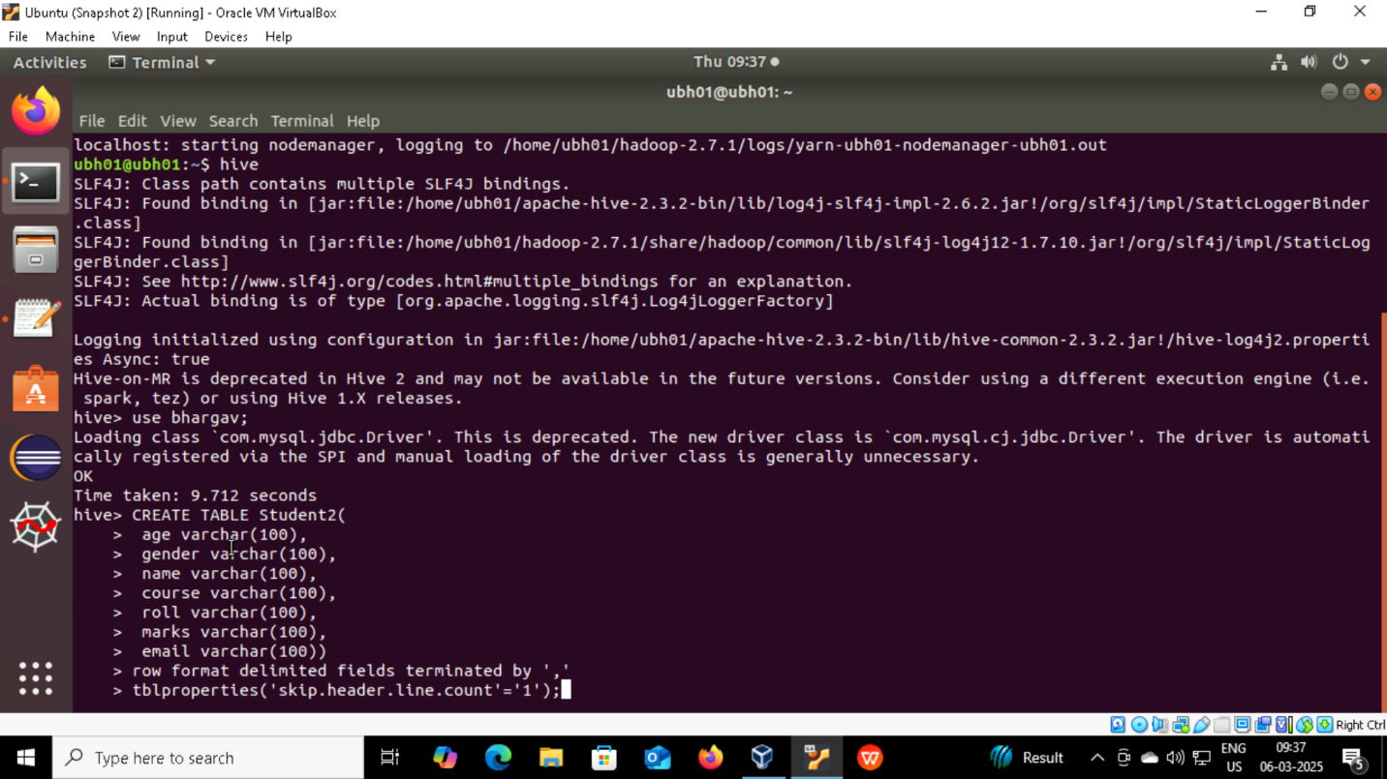

**Step 2. Load the data from the system into table**

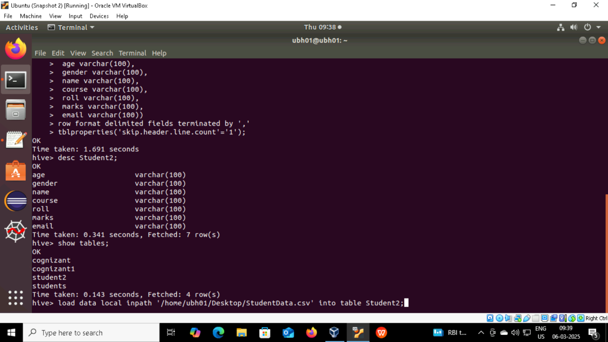

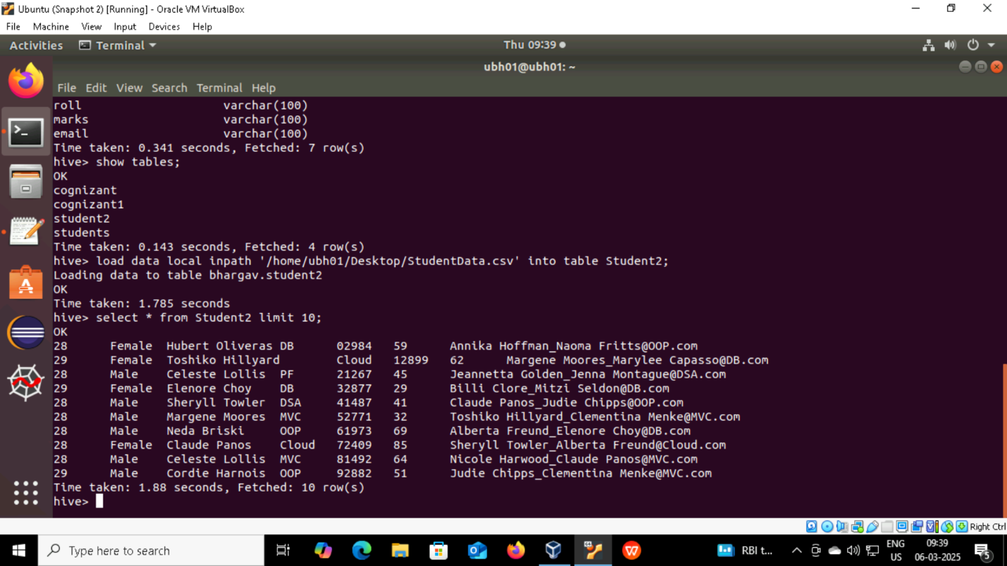

**Partitioning**

Partitioning in Hive involves dividing a table into smaller, more manageable parts based on the values of one or more columns. This helps improve query performance and data management.

**Static Partitioning**

**Step 1. Create a Partitioned Table in the Database**

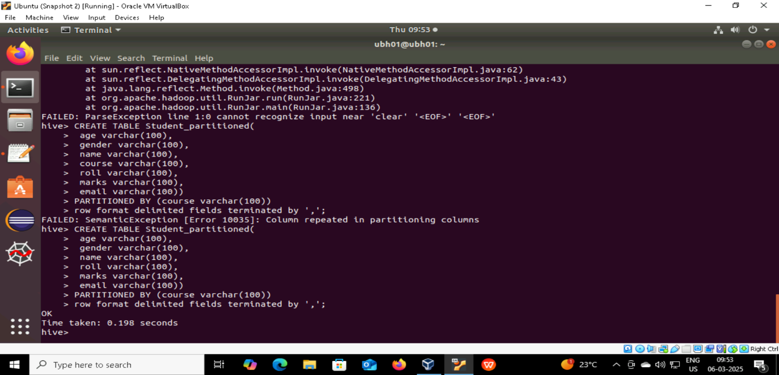

**Step 2. Insert the data into partition table**

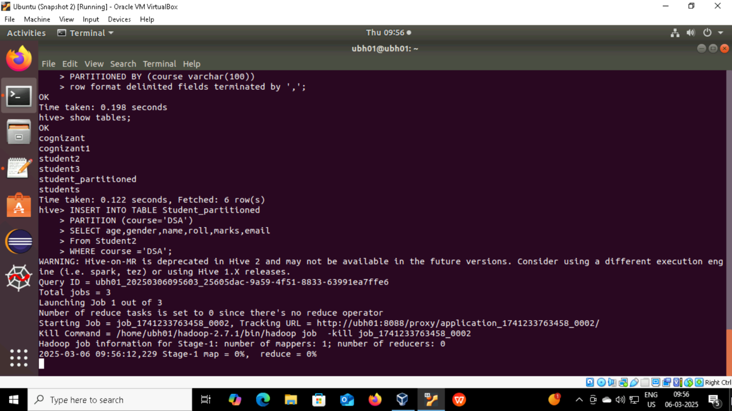

**Step 3. Run the following hdfs commands to check partition is done or not**

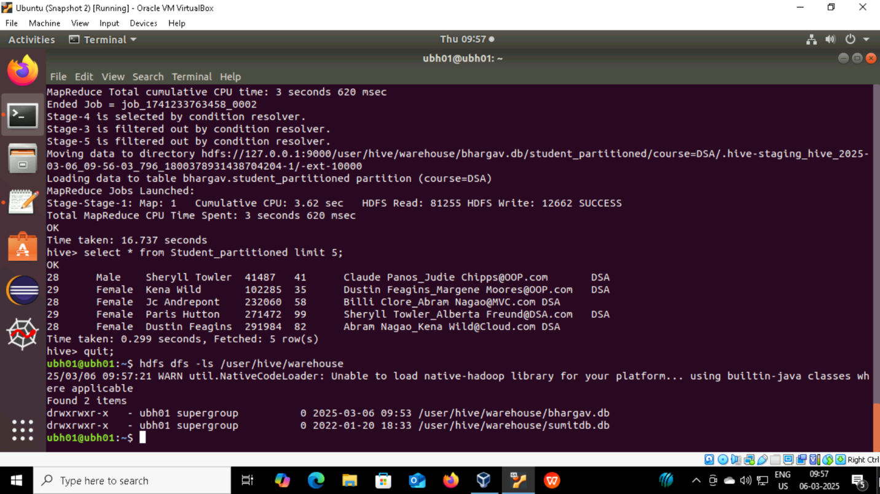

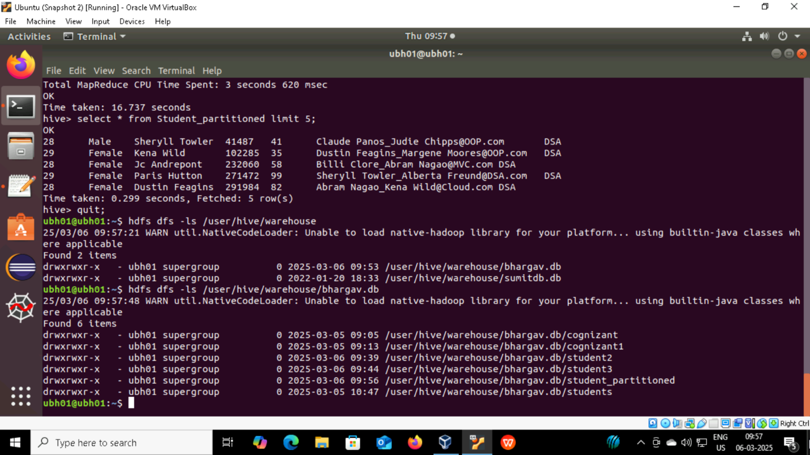

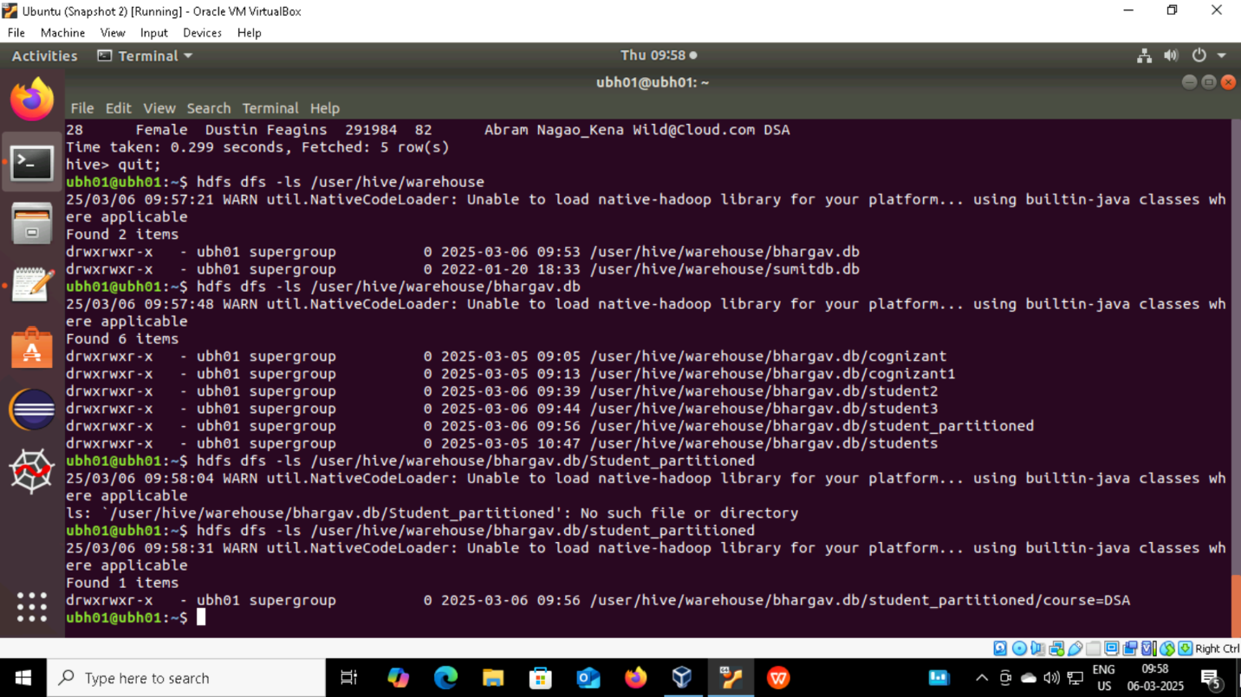

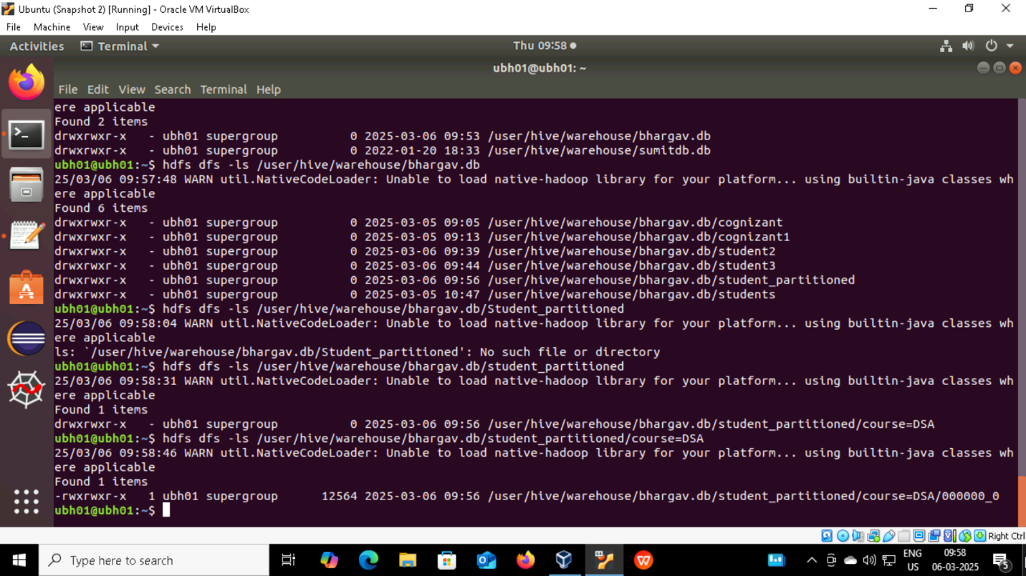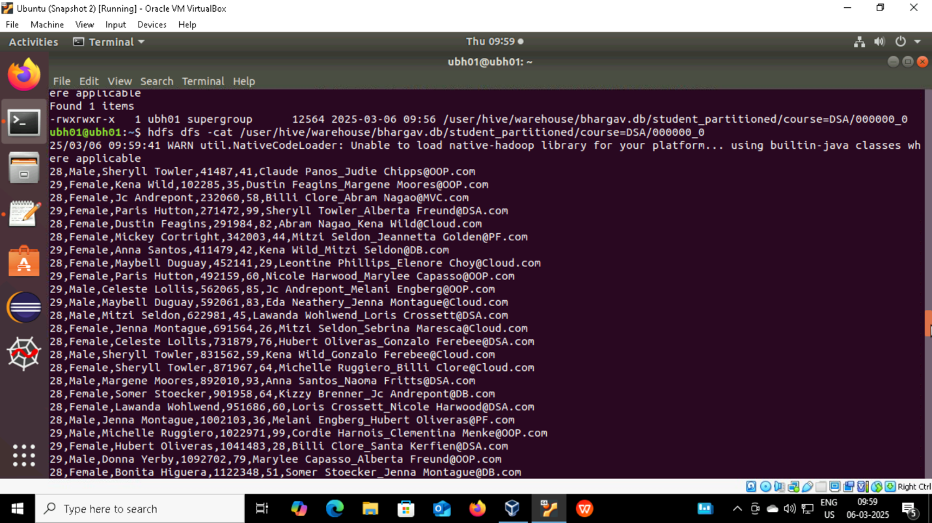

**Dynamic Partitioning**

**Step 1. Create a Partitioned Table in the Database**

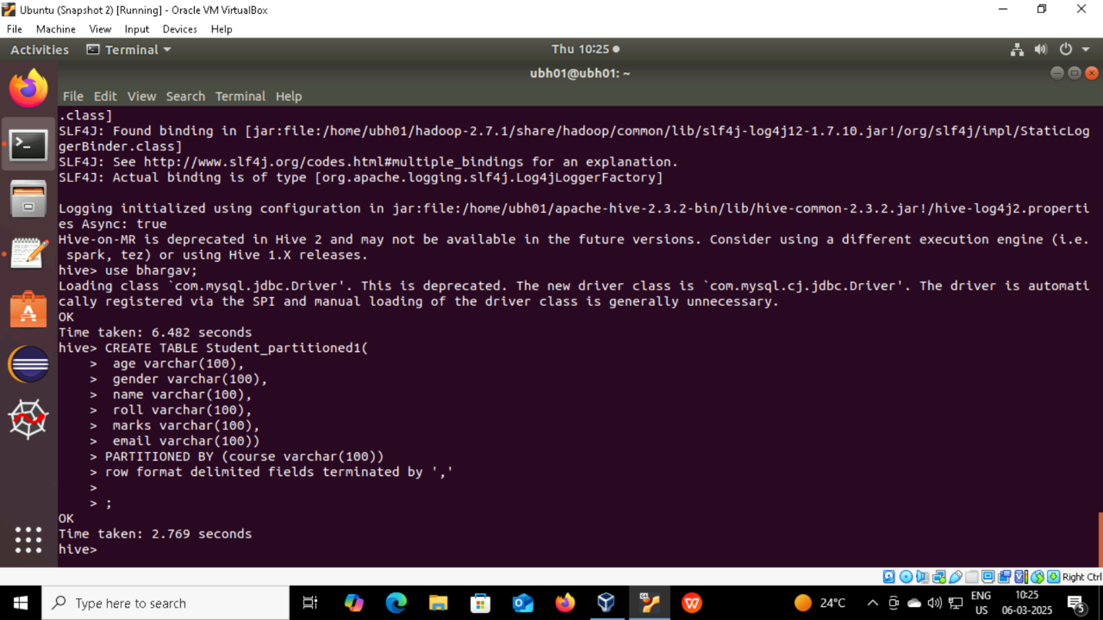

**Step 2. Set dynamic hive commands and insert data**

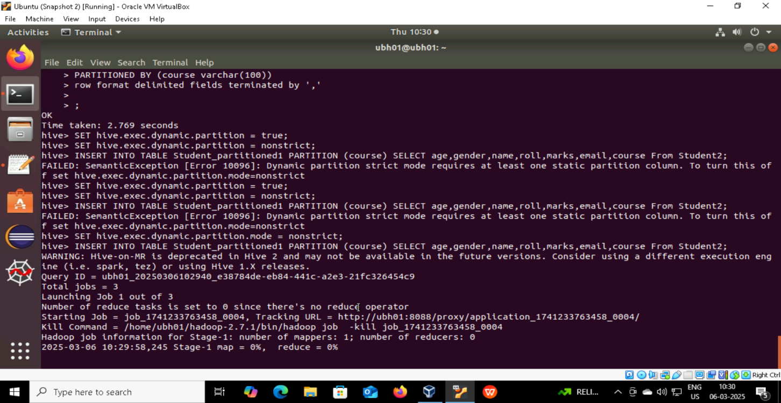

**Step 3. Run the following hdfs commands to check partition is done or not**

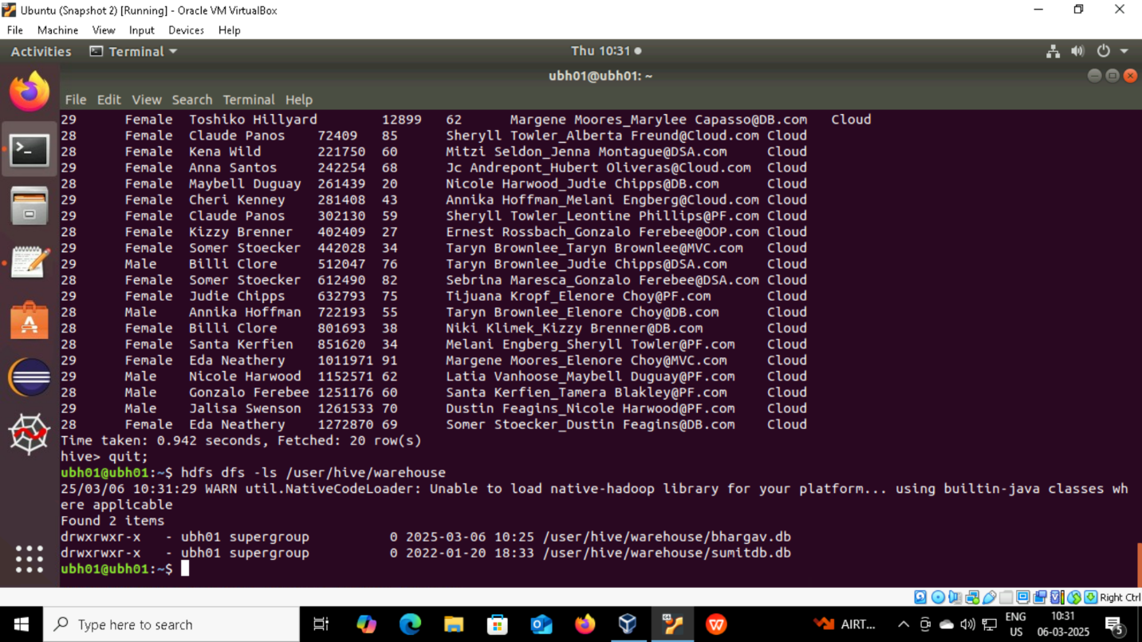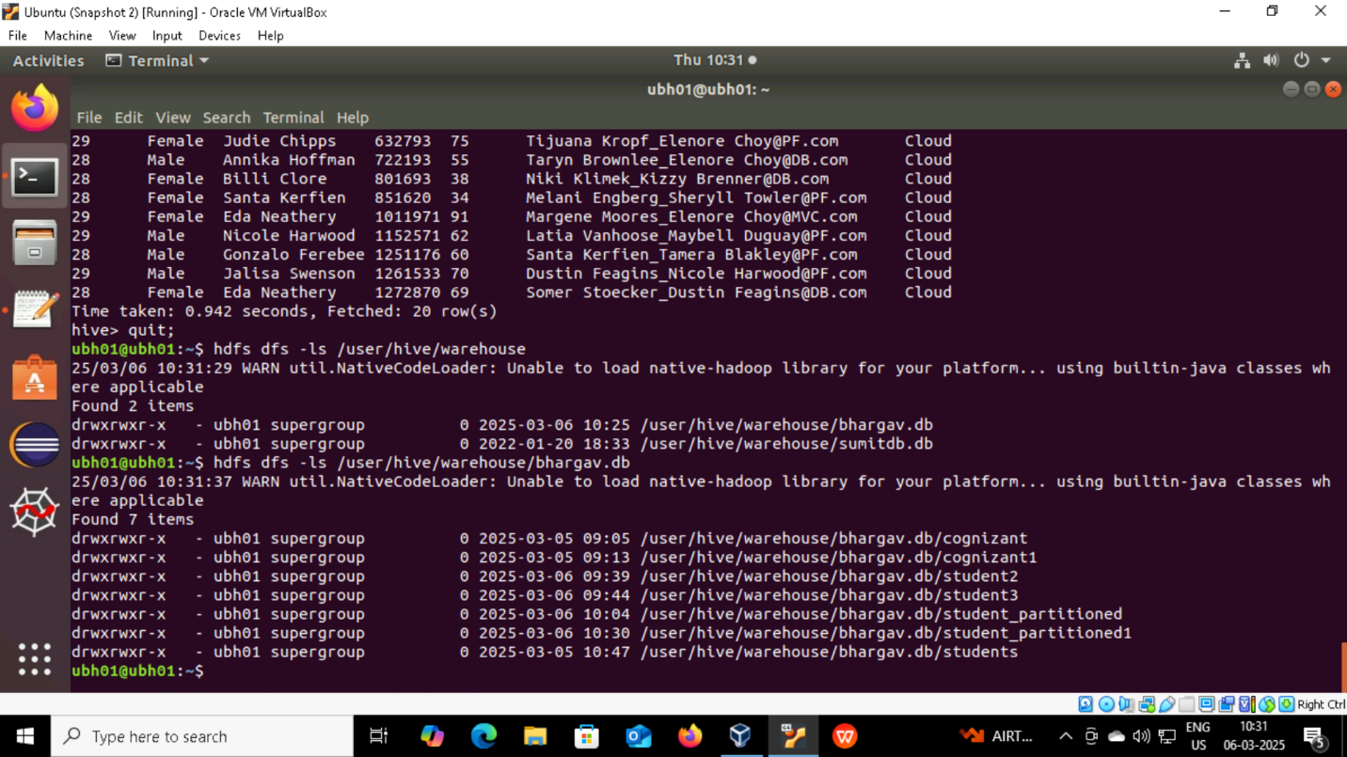

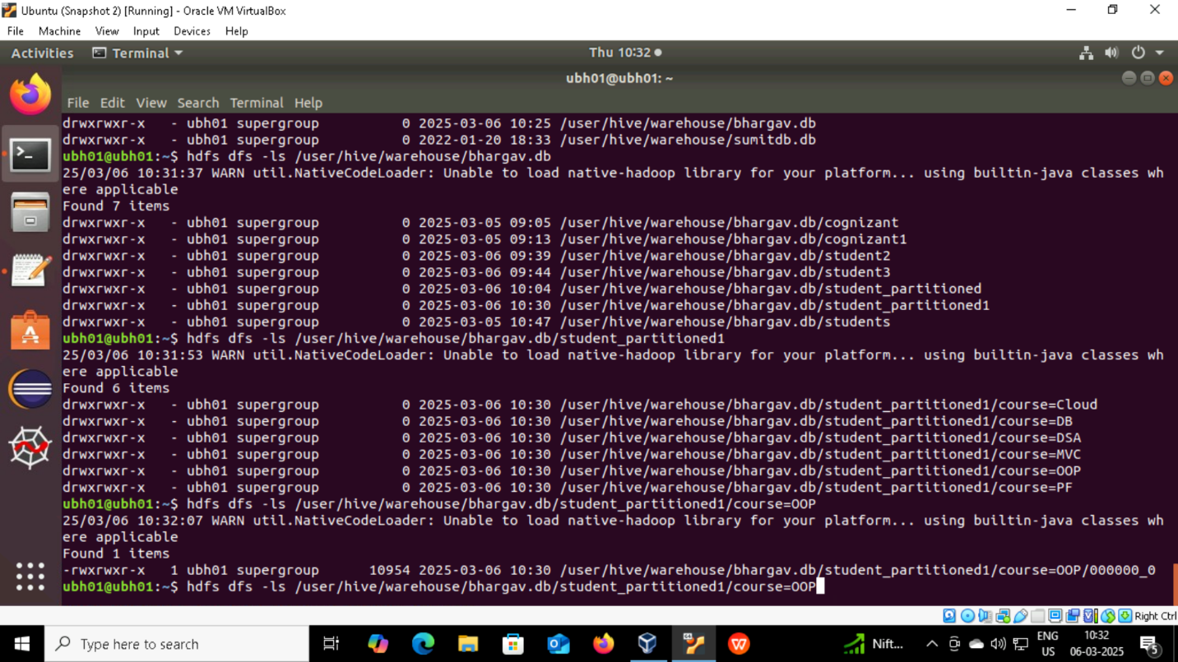

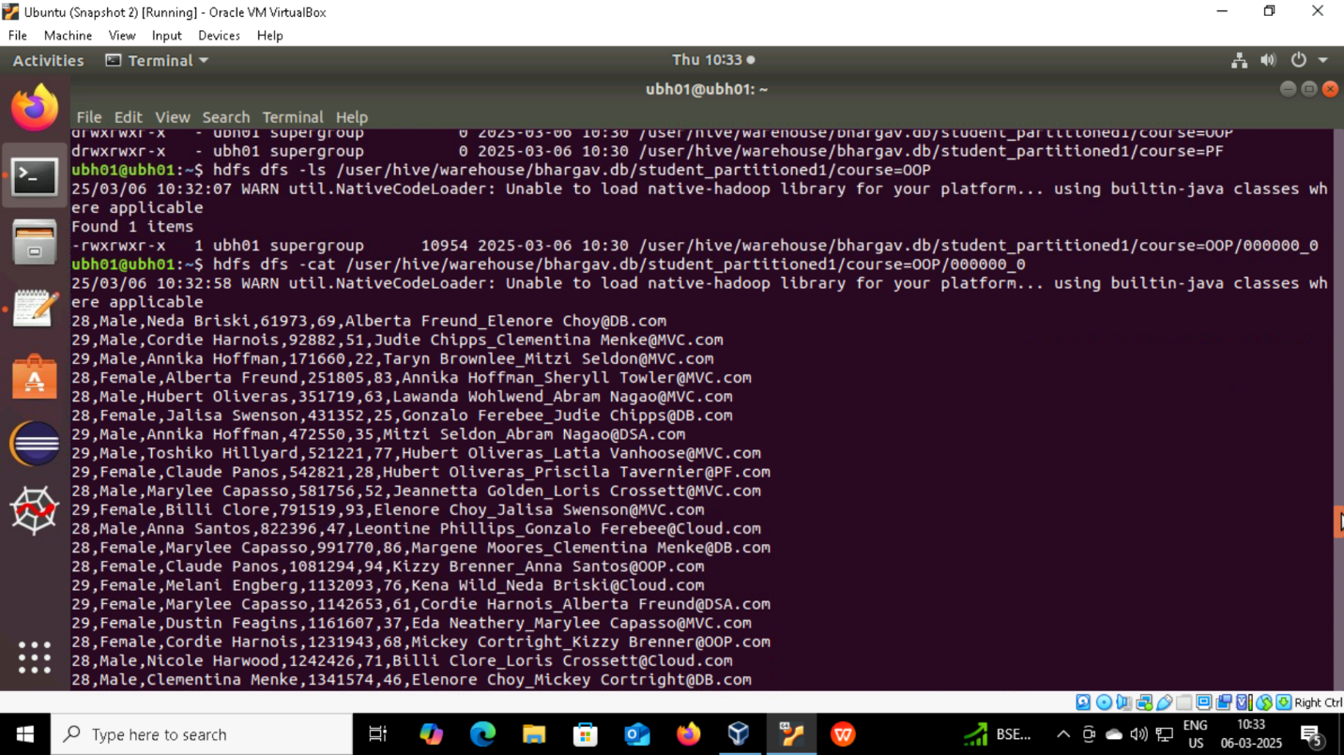

**BUCKETING**

Bucketing in Hive involves dividing data into a fixed number of files (buckets) based on the hash value of one or more columns.

**Step 1. Create a Bucketing in the Database**

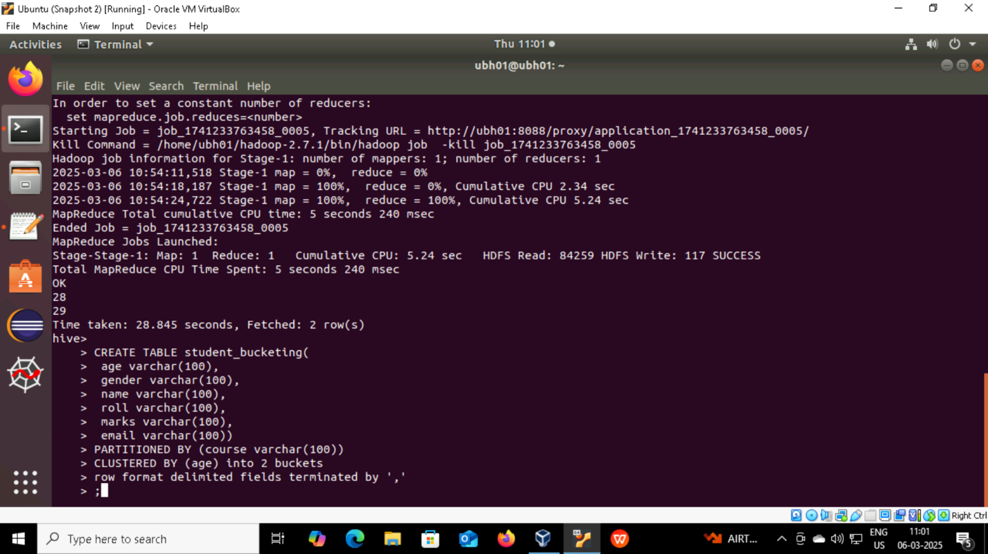

**Step 2. Set bucketing command & Insert the data into Bucket table**

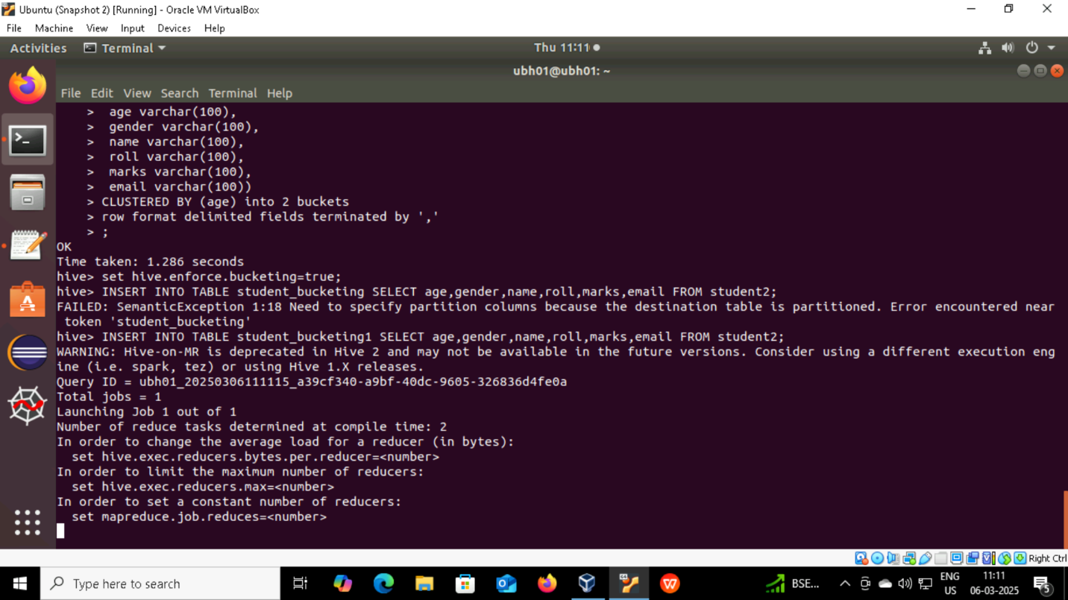

**Step 3. Run the following hdfs commands to check partition is done or not**

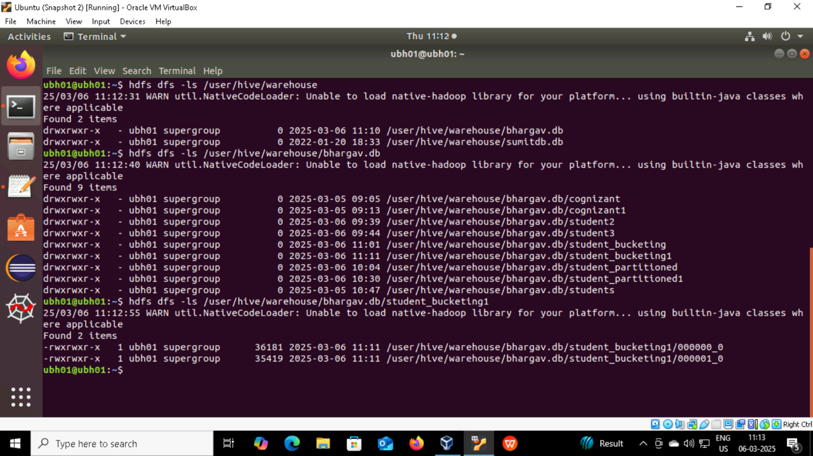

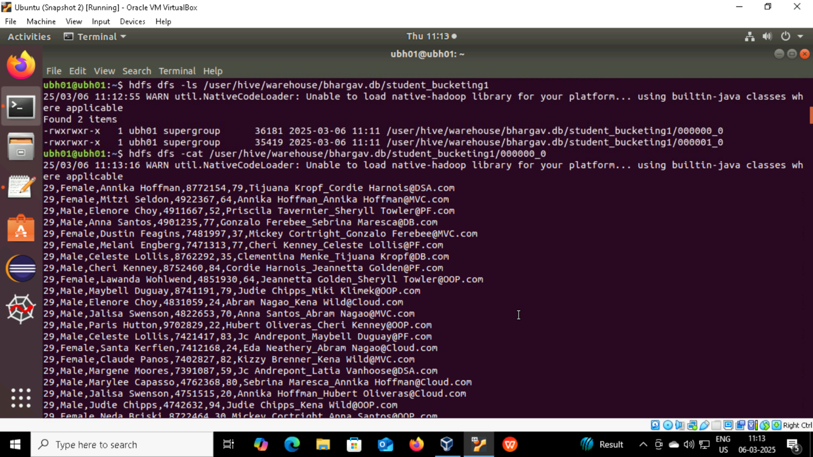

**Partitioning & Bucketing**

**Step 1. Create a table in the Database and Set commands**

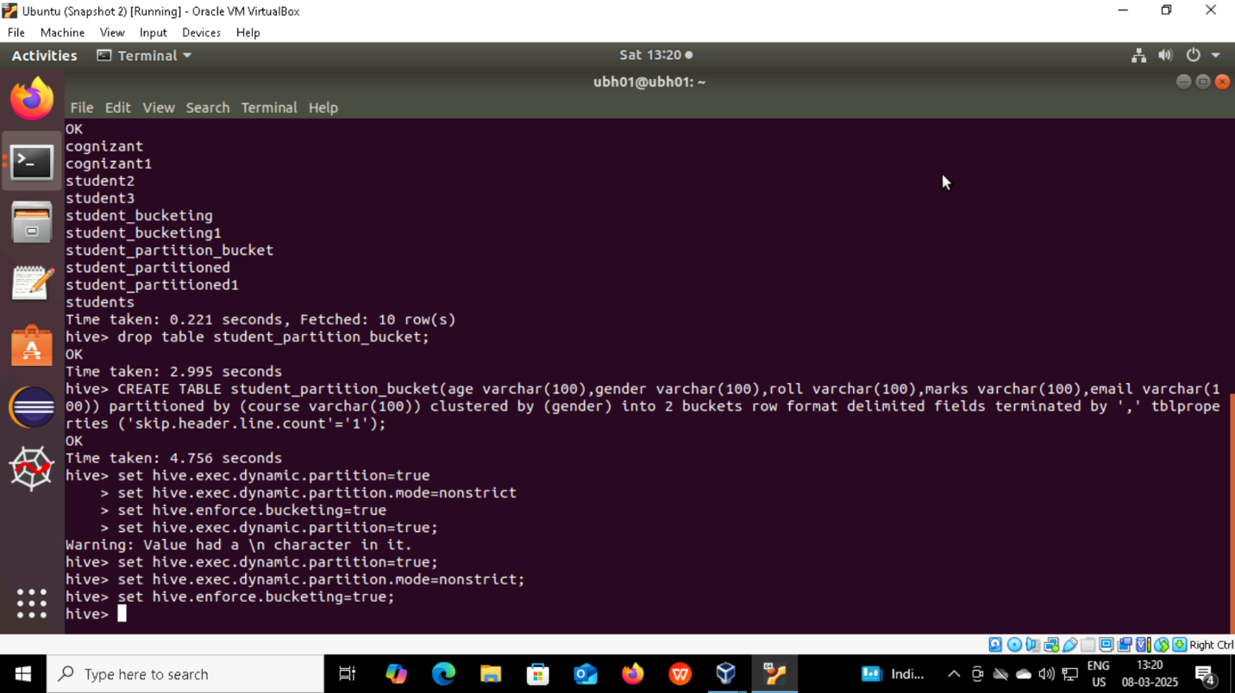

**Step 2. Insert data into table**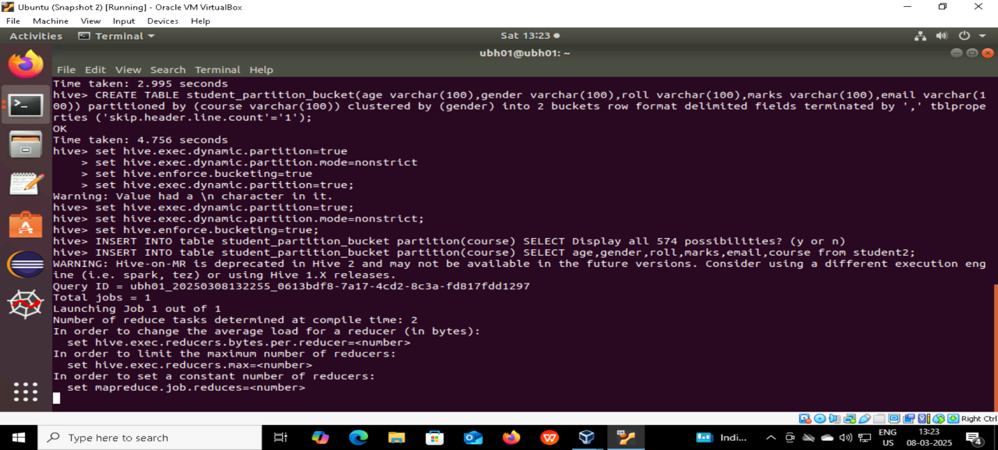

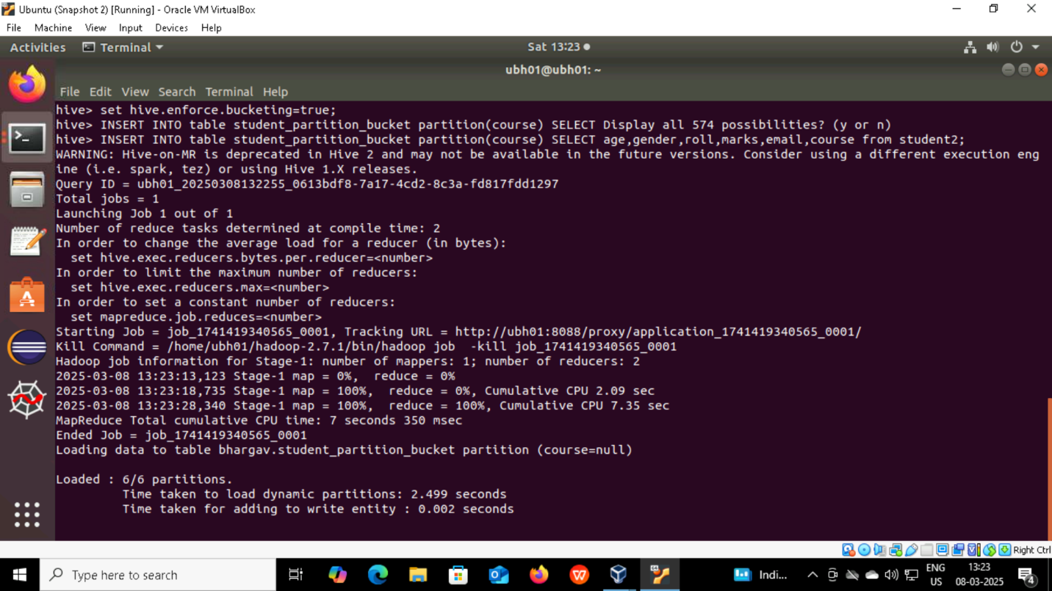 6/6 partitions are done

**Step 3. Run the following hdfs commands** 